Uniforms are required for new athletes only.
Please make all checks out to Saugus XC.
Turn in your uniform order by Monday, 6/26, to Coach Berns or Amanda Kasahara.
$90.00 Check or Venmo (@SaugusHighXC) Accepted.
($45 for top, $45 for bottoms)
Contact Michelle Velikorodnyy (805) 404-4982 if you need more time or assistance for payment.
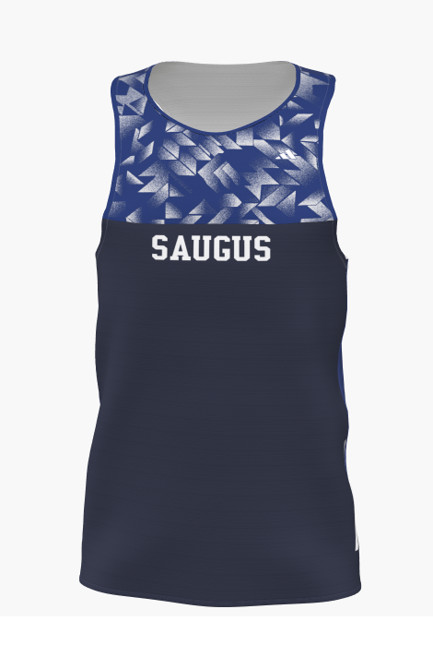 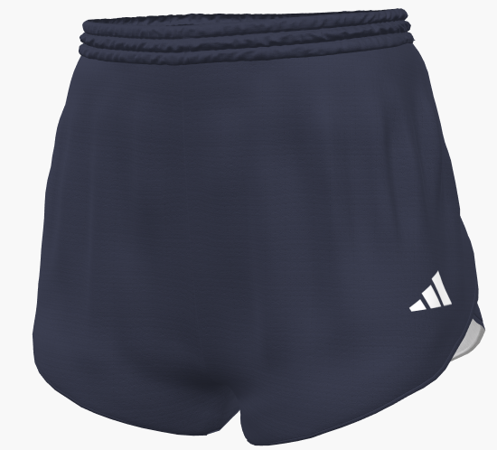OR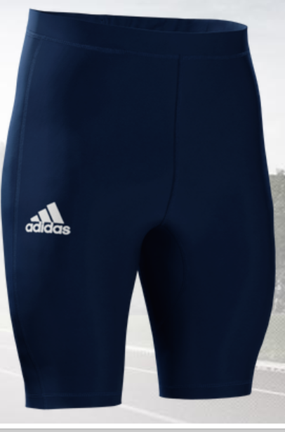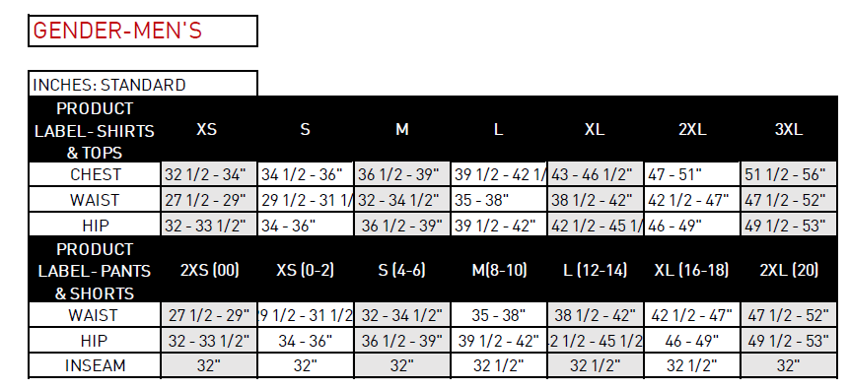

Athlete’s Name:
Top ($45) Size:
Bottom ($45 each) Size: Bottom Style (circle one): shorts or tights
(For planning purposes)Hoodie size:

Uniforms are required for new athletes only.
Please make all checks out to Saugus XC.
Turn in your uniform order by Monday, 6/26, to Coach Berns or Amanda Kasahara.
$90.00 Check or Venmo (@SaugusHighXC) Accepted.
($45 for top, $45 for bottoms)

Contact Michelle Velikorodnyy (805) 404-4982 if you need more time or assistance for payment.

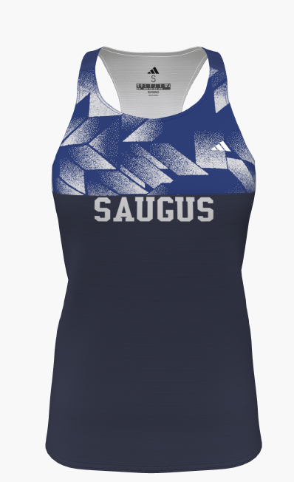 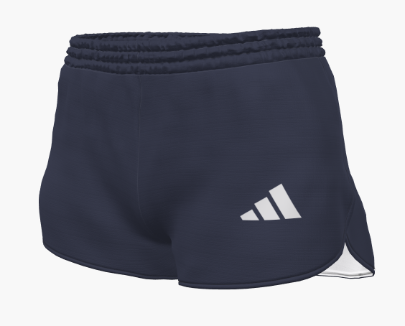 OR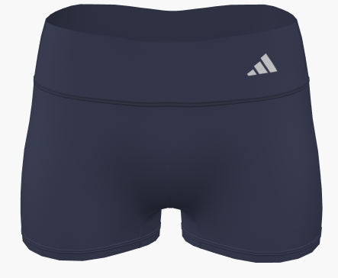
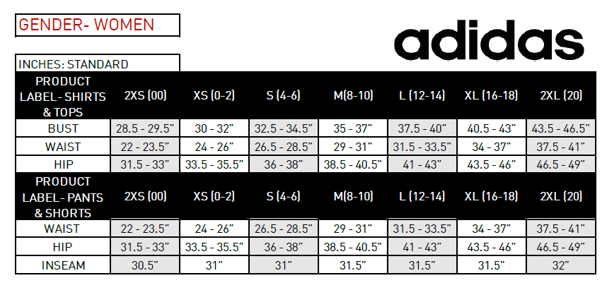

Athlete’s Name:
Top ($45) Size:
Bottom ($45) Size: Bottom Style (circle one): shorts or tights
(For planning purposes)Hoodie size:

