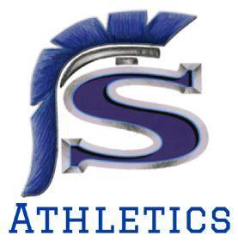

Welcome to Saugus High School’s Cross Country 2023-2024 Season! Cross Country is a fantastic sport, and we have amazing coaches and wonderful students at Saugus. As parents, we get to work together to support our team, students, and coaches. Thank you in advance for your help!

Communication: We will use Blast Athletics to provide you with information about the wonderful world of Saugus Cross Country. You must sign up for Blast so we can send you messages and keep you informed about events and opportunities to volunteer. https://www.blastathletics.com/teams/84967/join

Coach Berns will use Remind to communicate. Please join with this code: @fbefa34
BLAST

Volunteering: There are several opportunities to volunteer. We need people to set up the canopy for races and take it down. We need donations for the car wash, for frozen watermelon, and for Otter Pops. We need families to host the pasta feeds, and we need donations for pasta feeds. Please read your Blast updates and sign up to help as you are able.

Spirit Wear: Athletes will receive a team hoodie when 20 BLAST contacts are entered. With a team donation, all athletes will receive the team polo to wear on meet days. Other spirit wear may be purchased here: https://saugus-xc.psappareldesign.com/
SPIRIT WEAR

Instagram: Follow sauguscrosscountry.
Please do not hesitate to reach out with questions or ideas. You can contact us via Blast or cell. We look forward to working together for the team’s success. Your Saugus Cross Country Booster Club Board is here to help!
Sean Bryant (310) 947-2221,Treasurer Jenni Dion (661) 478-0590, Secretary Patti Ruiz, (661) 607-8932 Fundraising Amanda Kashara, (661) 803-9635 and Sheila Pearson, (213) 503-4853 Vice Presidents Michelle Velikorodnyy (805) 404-4982, President

