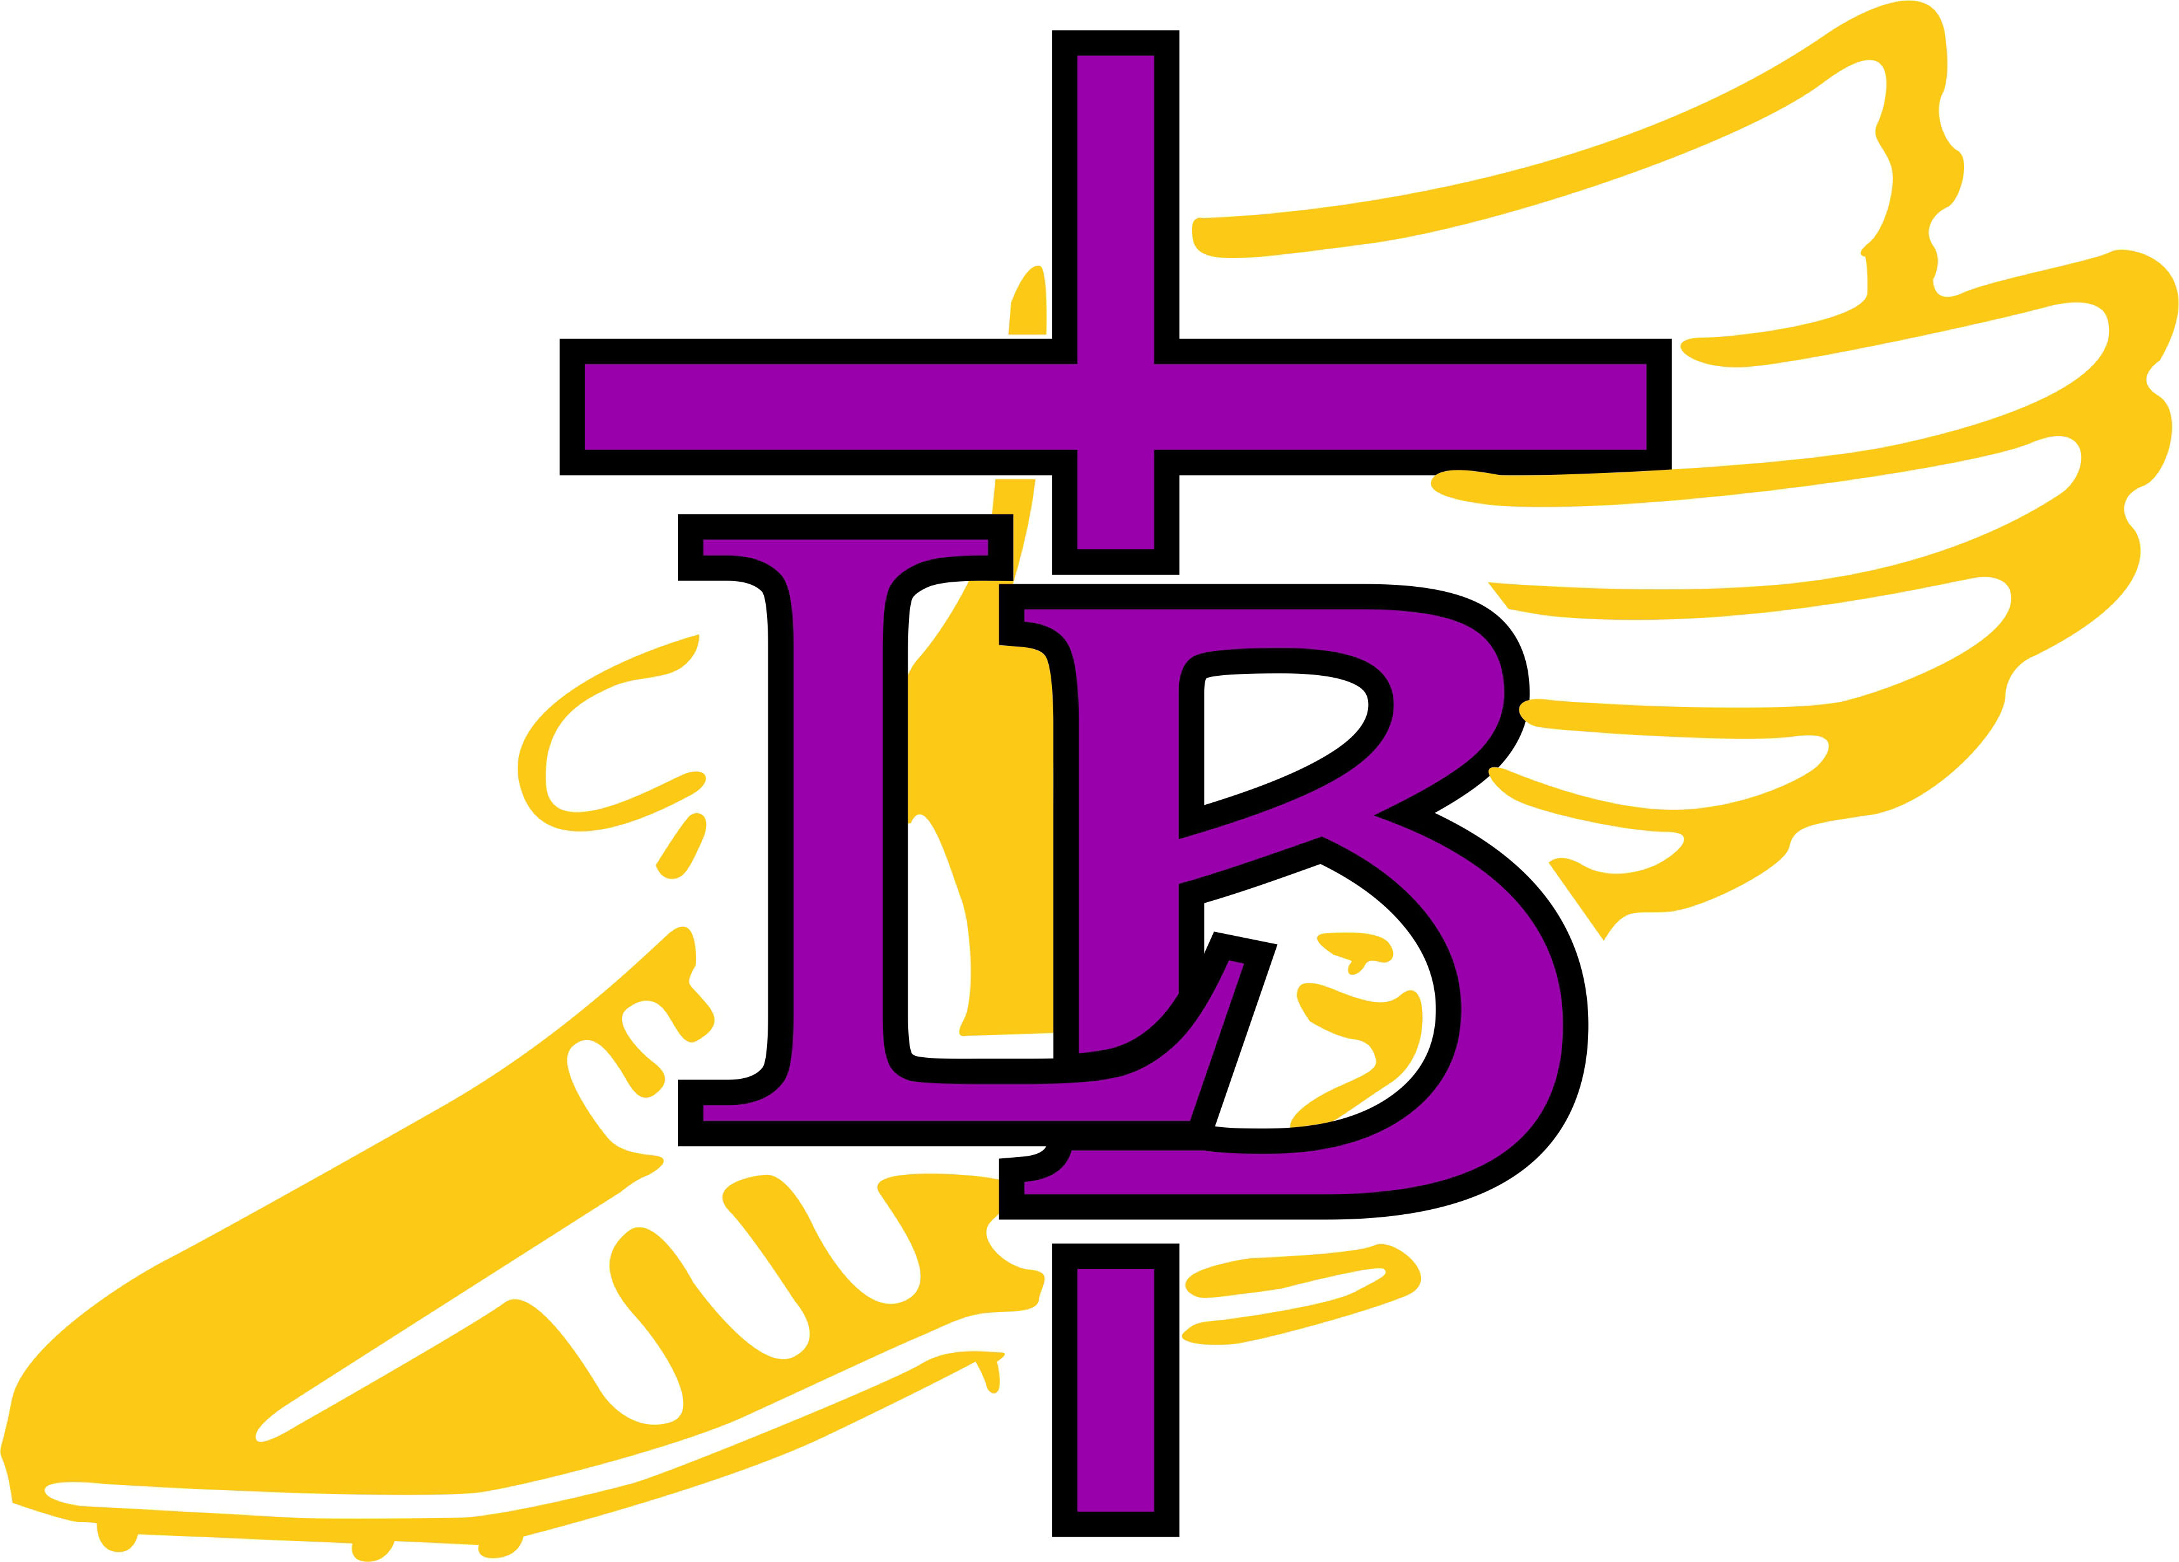

Bishop LeBlond High School Cross Country!

Spoofhound Invitational
Tuesday August 29, 2023

Bus Departs LB @ 2:15pm
Dismissed from class @ 2:00pm
Please change into your uniform promptly and load bus ASAP!

What To Bring:
Water Bottle
Running Shoes
Spikes (if you have them)
Extra Socks
Uniform
Warm Up Clothes (long sleeves, long pants)
Poncho, Raincoat
WATCH!

Lunches:
Lunches will be provided by the Crook family

Course:
The course is located on the campus of NWMSU and is 90% grass with a small section of turf connecting the course. Spikes are recommended!

Times:
3:45 pm—Coaches Meeting
4:15pm—JV Boys & Girls 3,200m
4:45pm—Varsity Girls 5,000m
5:20pm—Varsity Boys 5,000m
5:45pm—Middle School 1 mile Time Trial
6:10pm—AWARDS!

Awards:
Medals will be awarded to the top 15 individuals in the Varsity races and top 10 individuals in the JV races. Team plaques will be awarded to the winning boys and girls varsity teams.
(**NOTE** if you would like your athlete to ride home with you instead of the bus please notify Coach Gregg by text or email 24 hours in advance and SIGN YOUR ATHLETE OUT with Coach Gregg before you leave. There is also a form you will need to fill out (only once per season) for us to keep on file if you are taking a student home and they are not riding the bus. Coach Gregg has copies of that form. We ask that all athletes stay until the conclusion of awards! Email: gregglynn1055@gmail.com Phone: 8162948342)

Bus Parking:
Parking for buses will be at the South side of the Hughes Fieldhouse. Only on the West side of the lot. Overflow bus parking at Donaldson Westside Park.

Driving Directions:
Take I 29 North from St. Joseph
Merge onto 71 North towards Maryville
Turn Left on Business 71 into Maryville
Go .6 miles
Turn left on East Southhills Drive (stoplight)
Go 1 mile
Turn Right on Icon Road
Go 2 miles
Donaldson Westside Park is on the left-course is on your right.

Schools Participating:
Bishop LeBlond, Chillicothe, Creston, IA, East Atchison, East Buchanan, Maryville, Nodaway Valley (MO), North Andrew, Rock Port, Savannah, South Nodaway (Platte Valley), St. Joseph Benton, St. Joseph Lafayette

Course Map:

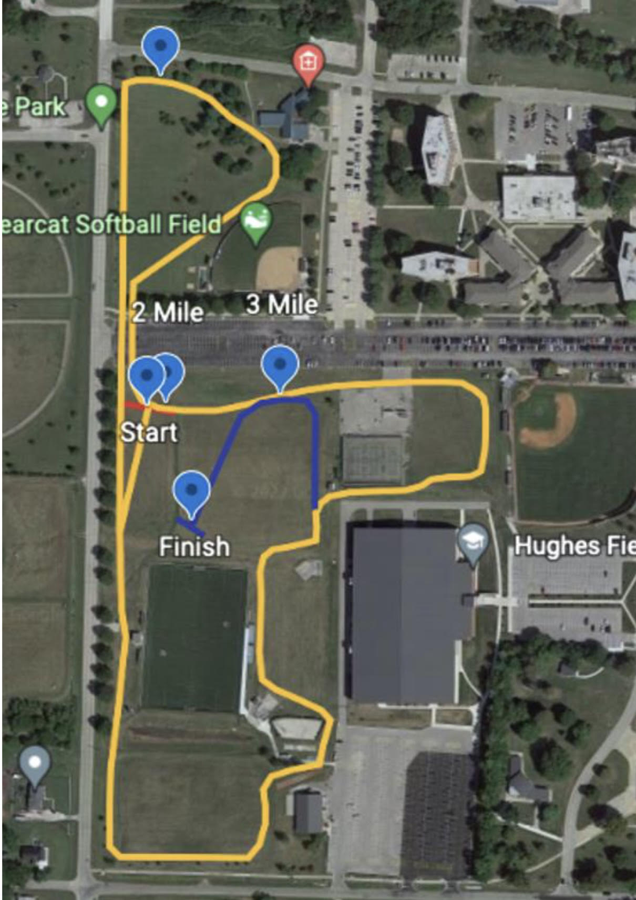

Course Map:



