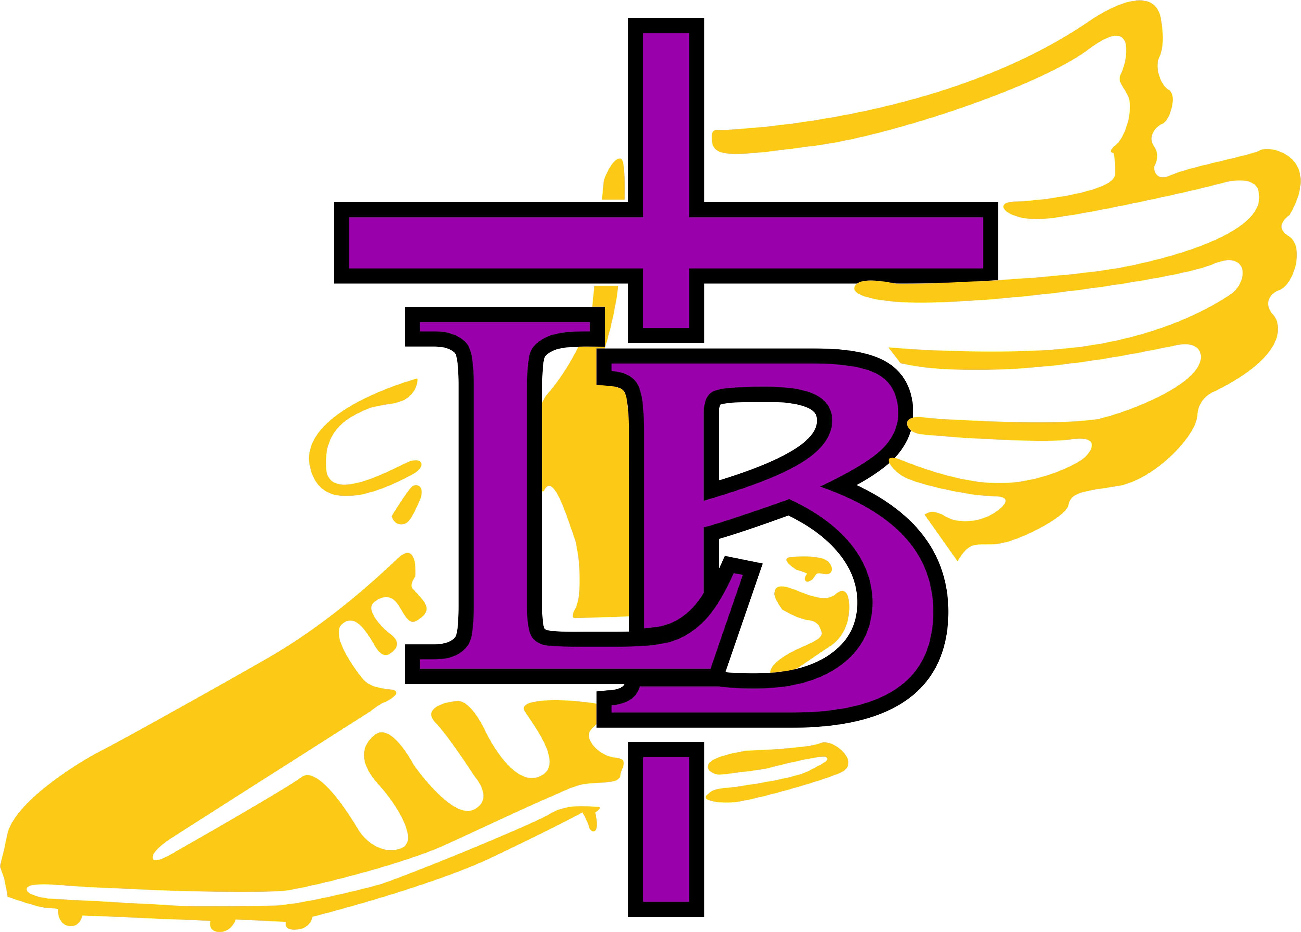

Bishop LeBlond High School Cross Country!

West Platte Invitational
Saturday, October 14, 2023

Please arrive at LB @ 7:00am!
Departing at 7:15am!

What To Bring:
Water Bottle
Running Shoes
Spikes (if you have them)
Extra Socks
Uniform
Warm Up Clothes (long sleeves, long pants)
Poncho, Raincoat
WATCH!

Lunches provided by the Eckstein Families

Course:
The course is located at Platte Ridge Park. Spikes are recommended.

Spectator Parking is at the SOCCER FIELDS! Please do not park on the road.

Times:
8:30am—Coaches Meeting
9:00am—Girls Varsity
9:35am—Boys Varsity
10:05am—Boys and Girls JV
11:15---Awards

Awards:
Varsity medals top 20 (11-20 given in chute-1-10 at awards after all races)
JV medals top 15
1st and 2nd place plaques

(**NOTE** if you would like your athlete to ride home with you instead of the bus please notify Coach Gregg by text or email 24 hours in advance and SIGN YOUR ATHLETE OUT with Coach Gregg before you leave. We ask that all athletes stay until the conclusion of awards! Email: gregglynn1055@gmail.com Phone: 8162948342)

Bus Parking:
Busses drop off and park west of baseball fields

Driving Directions:
Platte Ridge Park is located on 371, 2 miles north of the Weston/Tracy exit on I29.

Course Map:


