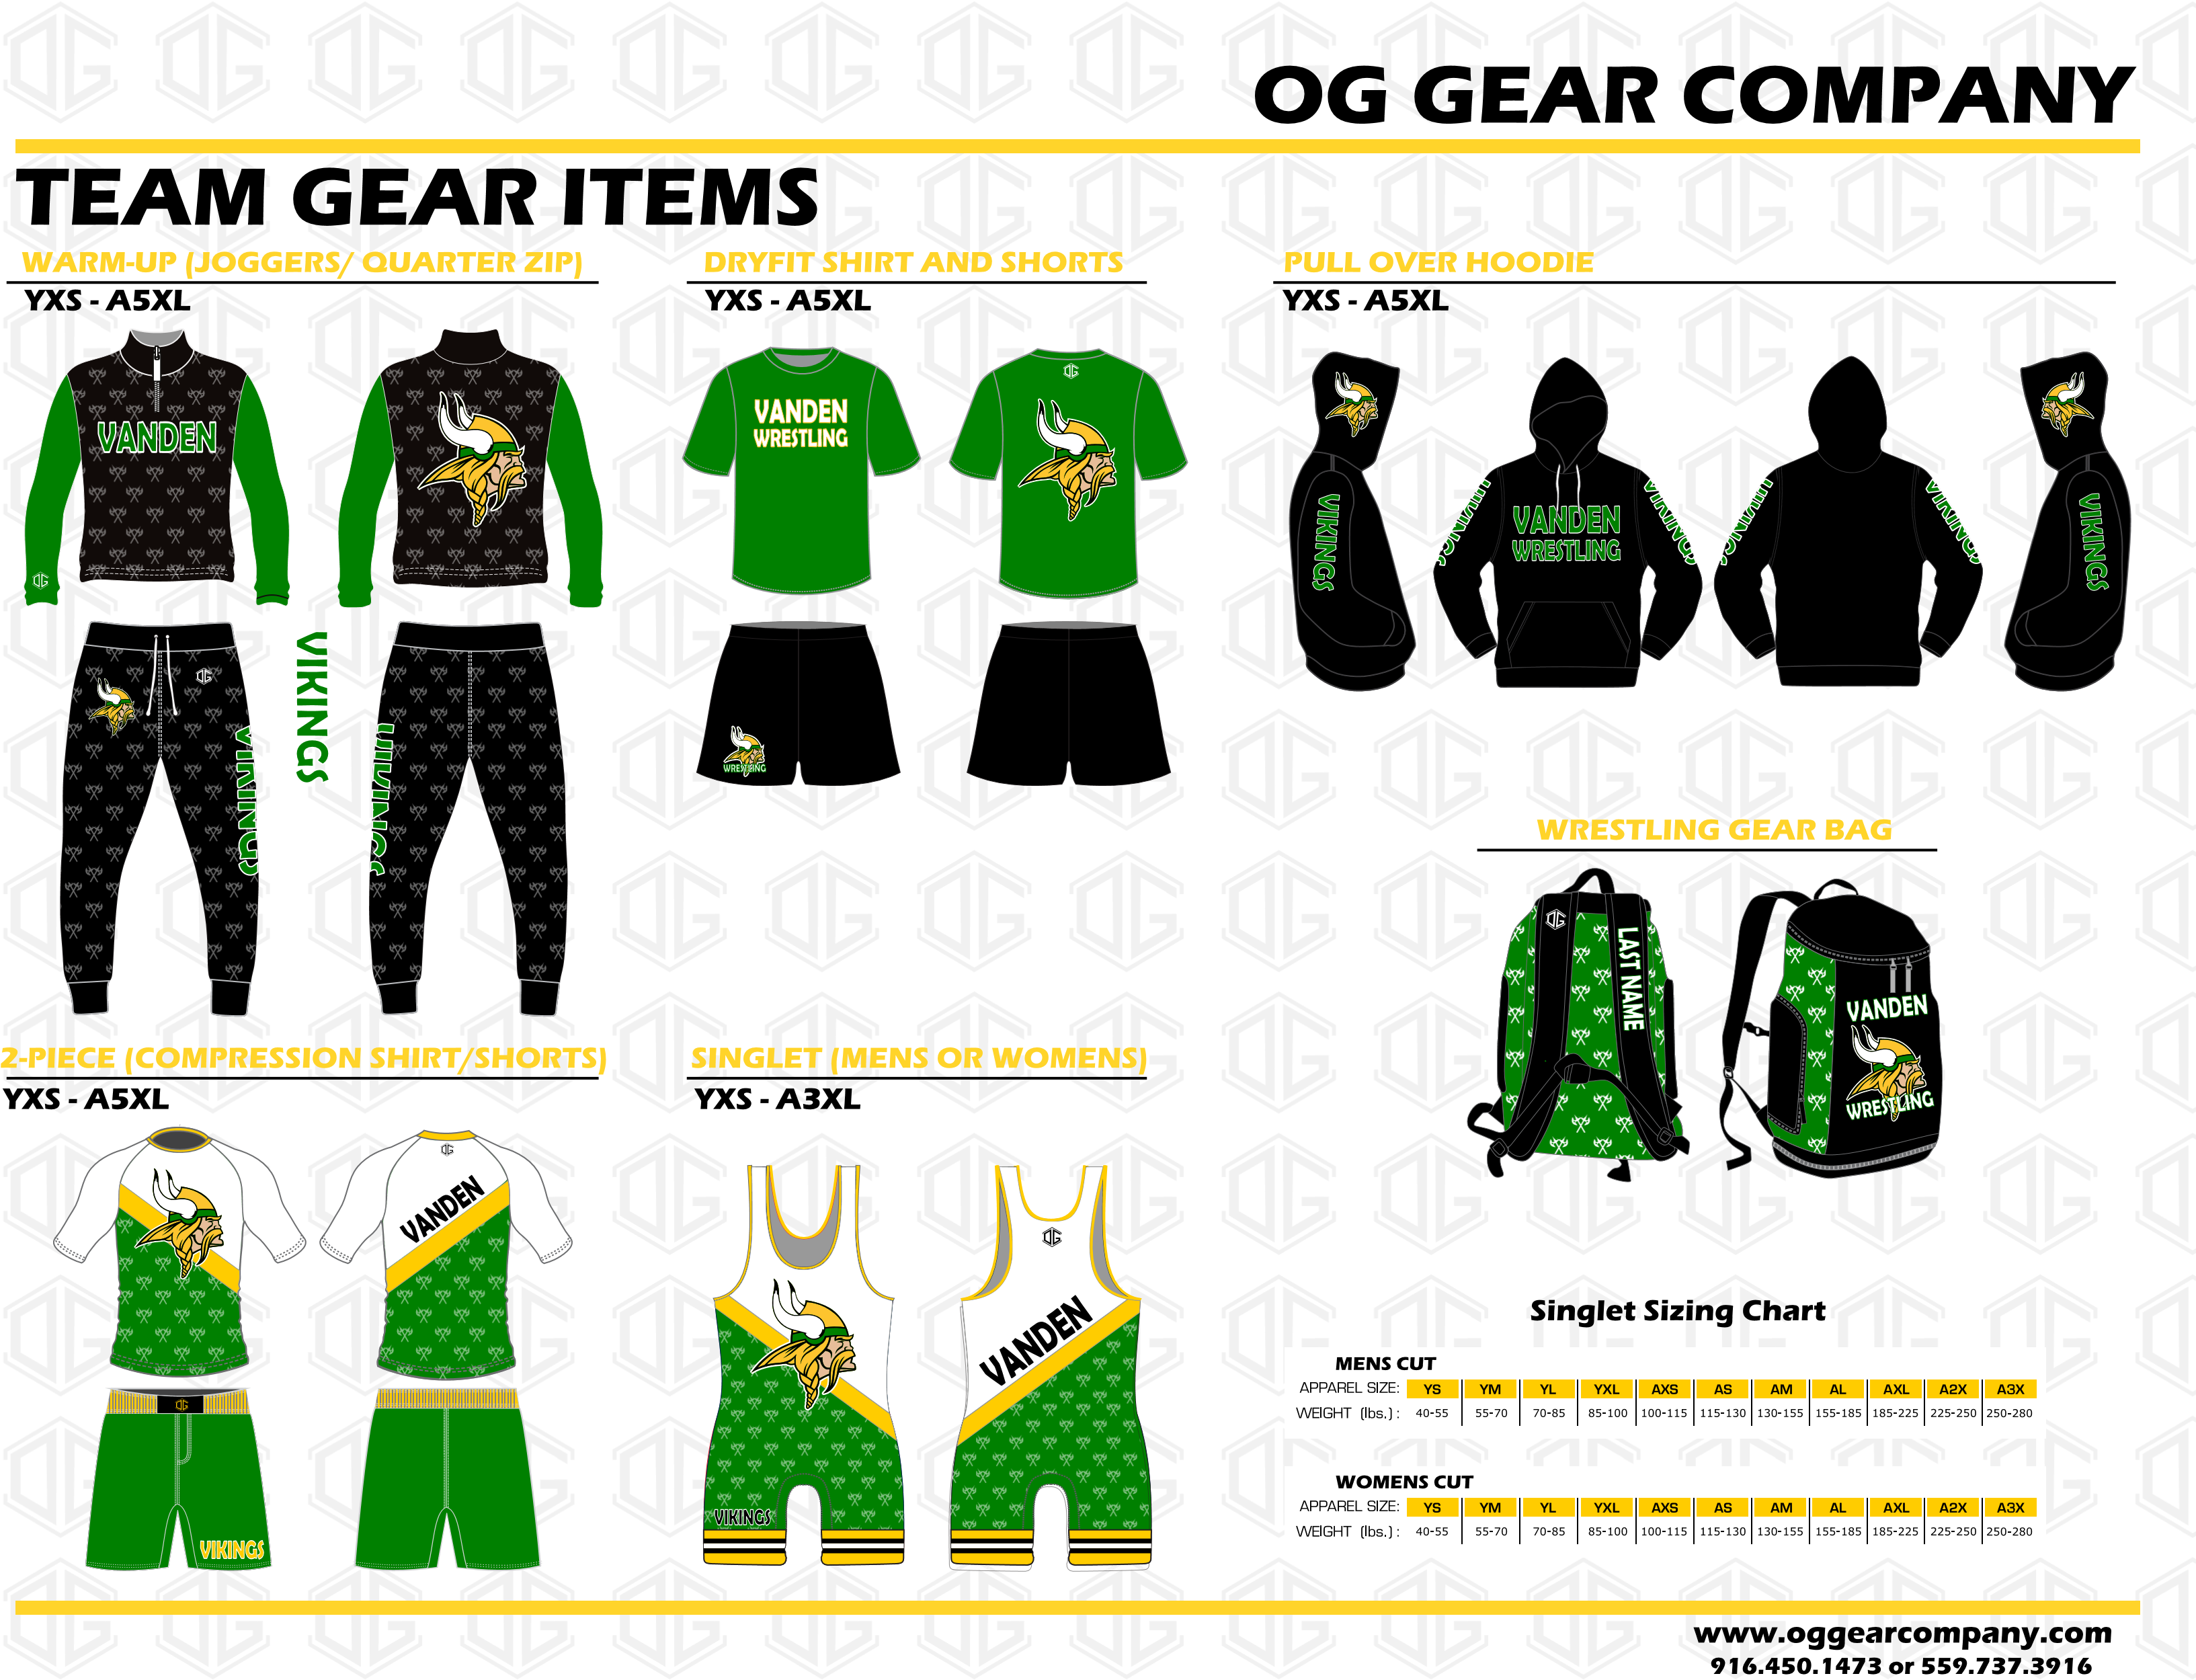

Vanden Team Gear Order Form
Package Deal | Size | Qty | Unit Price | Amount
Standard Package – Warm-Up, Dryfit, Workout  Shorts, & Hoodie |  |  | $150
Standard Package – Warm-Up, Dryfit, Workout Shorts, Hoodie, & Gear Bag |  |  | $200
Elite Package – All items from standard package with singlet |  |  | $235
Elite Package – All items from standard package with 2-Piece Uniform |  |  | $250
Ala Carte | Size | Qty | Unit Price | Amount
Singlet |  |  | $35
2-Piece Uniform |  |  | $55
Warmup |  |  | $75
Hoodie |  |  | $40
Quarter Zip (Only) |  |  | $40
Joggers (Only) |  |  | $40
Dryfit |  |  | $25
Workout Shorts - Mesh |  |  | $25
Gear Bag |  |  | $65
Customization Options | Name
Name for Gear Bag
Total

Wrestler Name:____________________________________________________________________
Payment Methods: Cash, Check (PLEASE MAKE CHECKS OUT TO VANDEN ATHELTIC BOOSTERS),
CashApp $vandenatheletics, Venmo @vandenatheletics (For both CashApp & Venmo please make the note -Wrestling Program, Name of Athlete, Spirit Package Purchase)

