Saugus Track and Field 2/26
What a great start to our season. We have had our first home meet and a few invitationals already. If you are just joining or missed our informational meeting, WELCOME to the 2023-2024 Track and Field Season! We are excited to come along with your athlete and the coaches as we begin another fabulous season. We thank you in advance for your support this season.
New To Track? We have two main areas within our program. The distance side trains for 400 meters or more. All athletes running 800 meters, 1600 meters and 3200 meters are coached by Coach Berns kberns@hartdistrict.org and Coach Sergey.
Sprints (400 meters or less), hurdles, jumps and throws are coached by Coach Standley cstandley@hartdistrict.org . It is important that each athlete follow their coach for specific information. Oftentimes throughout the season, these different groups will have different instructions or be in different locations as you saw last weekend.
Fees: The fee for the 2023-2024 Track season is $225. Athletes coming from another Winter/Spring sport and just joining (Soccer and Basketball) $150
There are 3 ways to pay:
- check payable to: Saugus Track and Field Booster Club, Inc
- Blast (see below)
- Venmo @saugustrack91350.
We ask that families pay this fee as quickly as possible if they have not done so already. We currently have $18,000 in season fees outstanding with a very low participation rate.
Fundraising: We have eliminated most fundraisers and chosen to use a BLAST email to elicit donations to our program. We have already collected $10,000 with this fundraiser. We ask that each athlete use their BLAST account to send 20 emails or texts. If 20 is not possible, we understand so please include as many as you can. Should a family prefer not to participate in the BLAST emails or texts. We ask for an ADDITIONAL DONATION of $150. Participants receive a free hoodie in appreciation of your donation efforts.
We currently have only 46% participation with emails and 8 families participating in the buyout. We have 65 athletes who have not entered any emails or participated in the buyout.
The other fundraiser that is planned will take place on April 1st. We are planning a half-day youth training camp. This will take place as part of your athlete’s practice on this day.
Communication will be coming from 3 different places. Please read closely to know where to get information.
Coach/Parent Communication Via Infinite Campus- Both Coach Standley and Coach Berns have your athlete listed as a student in a class. Due to this also being a class, they communicate with parents via Infinite Campus. The Booster Club does not have access to this program. Coaches do send meet sheets and information through Infinite Campus.
Coach/Student Communication via Remind-So that the coaches can also communicate with the athletes for meets and immediate information, each has their own group in Remind. This app is limited to 100 recipients so the coach may have asked that parents not be linked to Remind.
Parent Communication: Your Track and Field Booster Club will communicate exclusively through Blast. Please be sure you are signed up for Track and Field as most sports have their own Blast link. Once you join, please search through the feed and the messages to get caught up on any information. This includes photos, https://www.blastathletics.com/teams/104206
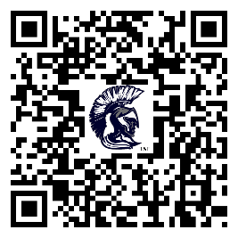
Photo Sharing: The BLAST platform allows you to upload photos. Athletes can also make their own showcase that can be seen by your sponsors and other coaches. It is a great way to get recognition and share success.
Uniforms: Coach Standley spearheaded uniforms. The window for ordering uniforms closed last month but your Track and Field Booster Club did purchase a few extras for athletes joining late. All questions regarding additional purchases of singlets and shorts should be directed to Coach Standley at cstandley@hartdistrict.org
Warm-up T-Shirts: In addition to the singlet (jersey) and shorts, coaches asked that each athlete purchase a $15 cotton warm-up T-shirt. This shirt has our new logo on the sleeve with “2024 athlete”. Athletes do have the option of upgrading to a higher quality dry fit version of the shirt.
- Athletes who filled out the size request can pick up their shirt from the booster club and reimburse us the $15 as we ordered at a bulk rate earlier in the season
- Athletes just joining track should check with the booster club or Pam a PS Apparel before ordering.
All other spiritwear can be purchased through PS Apparel Design. https://saugus-track.psappareldesign.com/
Spirit Wear: We highly suggest purchasing the team polo as athletes traditionally wear these polos to school on meet days. The warm-up sweats are also recommended. There is a FREE matching sweatshirt. More Information is listed above in Fundraising.
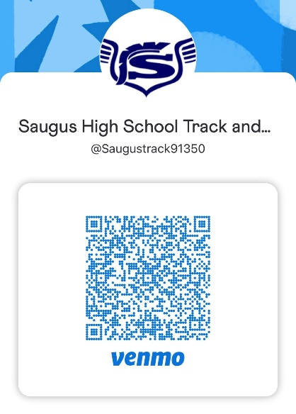
Your 2023-2024 Track and Field Booster Club

