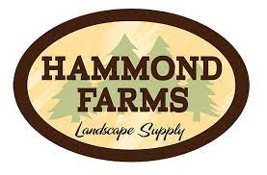
Holt Men’s Lacrosse Mulch Fundraiser
Quality bark from Hammond Farms
Created from virgin pine bark, NOT RECYCLED PALLETS, which make a more natural product. Pine is ground to a medium-fine texture and plenty of environment safe color to make vibrant, consistent colored mulches that we believe are the nicest products available.

