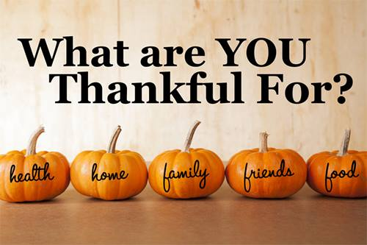
Don Lugo HS
Thanksgiving
Food Drive
Donations Accepted
November 4-November 15, 2019
(Room 204 or ASB Office)
Distribution November 19, 20 & 21
Room 8/10 from 2:30 p.m.-5:30 p.m.

