**Coupon #________________**

**Holt High School Men’s Lacrosse**

**Bulk Mulch Coupon**

$25

$25

Present this coupon to Hammond Farms and receive 10% off your order of any HF Select Colored Mulch or Twice Ground Red Pine up to 35 yards.  
**Dimondale location only  
5834 N Michigan Rd. Dimondale, MI 48821**

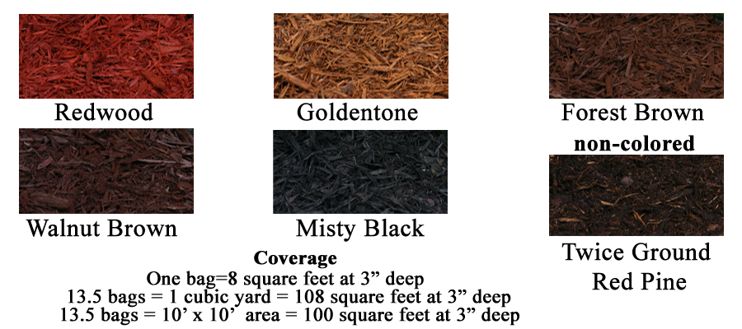

Limit 1 order per coupon.   
*Must be ordered between 5/15/24 – 8/31/24*.

Coupon sold by: ___________________________ Date: _______________________

____________________  
Customer Email

__________________  
Customer Phone

__________________  
Customer Name