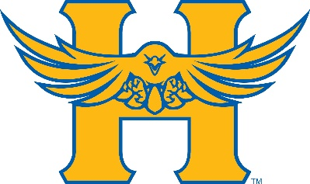
Hutchinson JV Invitational
May 7th, 2024

2:00 Coaches Meeting – Press Box
2:30 Girls Javelin – Boys to follow (Hosted at Don Michael Field)
Boys Shot Put – Girls to follow
Girls Discus – Boys to follow
Girls High Jump – Boys to follow
Boys Pole Vault – Girls to follow
Boys Long Jump – Girls to follow
Girls Triple Jump – Boys to follow

3:00 Girls 4 x 800 Relay
Boys 4 x 800 Relay

4:00 Girls 100M Hurdles
Boys 110M Hurdles
Girls 100M Dash
Boys 100M Dash
Wheelchair 100M Dash
Girls 1600M Run
Boys 1600M Run
Wheelchair 1600 Meter Run
Girls 4 x 100M Relay
Boys 4 x 100M Relay
Girls 400M Dash
Boys 400M Dash
Wheelchair 400M Dash
Girls 300M Hurdles
Boys 300M Hurdles
Girls 800M Run
Boys 800M Run
Girls 200M Dash
Boys 200M Dash
Girls 3200M Run
Boys 3200M Run
Girls 4 x 400M Relay
Boys 4 x 400M Relay

