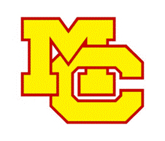
2019 MCHS Sundevils Wrestling

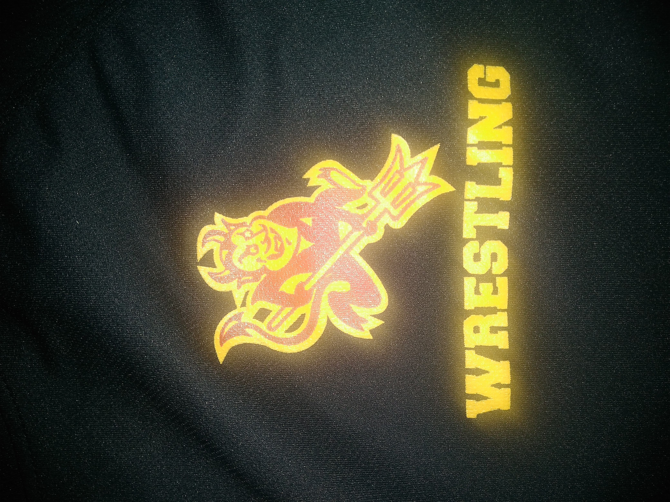
Welcome to our MCHS Sundevil Wrestling Program. We are excited for a great season! Wrestling season will be here before we know it and we encourage you become part of the Booster Club family. Please note, the off- season conditioning program is completely separate from this winter packet of information and donation request.

MCHS Wrestling believes that personal and academic growth is equally as important as the development of athletic skill. As a member of the program, there are certain expectations required of each wrestler. We expect all wrestlers to study hard and practice hard. The core mission of the program can be described in five words: Family, Appreciation, Industrious, Trustworthiness, and Hope (F.A.I.T.H). Our coaches work hard to develop and instill these ideas in our wrestlers and conduct the program in a manner that sets an example for good sportsmanship.
There is no public funding for high school sports. MCHS Wrestling cannot provide a quality program without the help of its families and the community. A wrestling program is costly and funded by donations and fundraising. Cost per player runs $400 for the season. This includes: Maintenance of wrestling mats, weight management tests, tournament fees, Van/Bus transportation, Hotel lodging, wrestling stipends for assistant coaches, the care of existing uniforms and the purchase of new singlets, miscellaneous fees associated with home based dual meets and tournaments and an end-of-season banquet for the team. Overall, the cost is about $25,000 per year. These funds WILL ALL go to Wrestling.

We are in need of the wrestling communities support. WE need your help! Your support in this most important endeavor will be greatly appreciated. Wrestling means so much to our community and I am excited about the opportunities we will be providing. If you are a company or small business any donation is tax deductible. We can provide a 501.(3)c form for your deductions. Make checks payable to “MCAF”

The Booster Club is the volunteer organization that supports the coaching staff, coordinates team activities and raises funds to defray everyone’s overall costs. YOUR HELP IS AN ESSENTIAL COMPONENT TO SUCCESS. All families are part the Booster Club. The PAC (Parent Action Committee) is the core group to coordinate with all supporters for all activities during the season. Dual meets and Tournaments are more fun if you know the person cheering next to you. If you already know you would like to assist the program, don’t be shy, contact us or we’ll be in contact with you.

Following is a checklist for the winter. We look forward to working with you during this exciting time in your wrestler’s life. If you have any questions, please contact any of the Booster Club officers listed below.
*This is our third year of the booster club program and your help is needed*
P.O.C.- Ron Simmons (President) Ron.Simmons@gmail.com

2019 MCHS Sundevils Wrestling
Winter Checklist

Suggested Donation. It costs approximately $400 per player but the suggested donation is only $275. You are also asked to volunteer for the end of the year FRESHMEN AND JV COUNTY CHAMPIONSHIP TOURNAMENTS, participate in fundraising efforts throughout the year as part of the Booster Club. Your generosity is appreciated and is tax deductible! Ask your employer if they have a matching program to double your contribution! Please speak with Booster Club Liaison, Coach Allan (AllanCabanilla@gmail.com), if you have financial difficulties. Payment plans are available.

Transportation. Wrestling is a Tier 2 sport and transportation is $70 per player, included with your suggested donation.

Booster Club. The Booster Club is the parent volunteer organization that supports the coaching staff, coordinates team activities and fundraisers to defray your overall costs. Attend meetings and be an active part of the family.

Booster Club – You are ALL part of the Booster Club and ask that you give your time to support your wrestler and the rest of the team in any way you can with team functions and fu7ndraising efforts.

A Mt. Carmel Sticker will be given to you to show your support in our High School Wrestling program.

Fundraisers. Various fundraisers are conducted throughout the year, some earn us $ at no cost to you. All we ask is to show your support and participate in our family and friend activities!
ONLINE SHOPPING FOR YOUR FAVORITE STORES GO TO… GET THE APP OR SAVE IT TO YOUR DESKTOP.

https://www.flipgive.com/teams/80863-mt-carmel-high-school-wrestling

Website and email Distribution. Stay informed! Read your texts. Add our Google calendar from the website to yours and automatically stay on top of important dates through your smart phone GroupMe App though IOS or Android. Just scan the QR code down below.
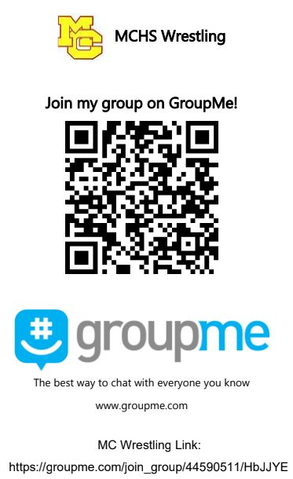
2019 MCHS Sundevils Winter
Registration Form

PLAYER’S Name: 2019-2020 Grade Level: (circle) FR SO JR SR

Email: Cell:

Mother’s Name:
Email: Cell:

Father’s Name:
Email: Cell:
In Case of Emergency (other than parents)
Name: Phone:

Registration in this program will add your email address(es) to the Booster Club/ GroupMe database. All information regarding the program is made via text message or Email. You may opt out of receiving texts/ emails at any time.

 | Quantity | Amount | Total Amount
Suggested 2019/2020 Season Donation (tax deductible)  (Contact us if you have financial difficulties or need a payment plan) | 1 | $275
(Booster Club) Volunteer “BUY OUT” | 1 | $50
Total
Make Wrestling donation checks payable to MCAF. Memo: WRESTLING PROGRAM
For “BUY OUT“ make check payable to Mt Carmel Booster Club. Memo: Buy out

