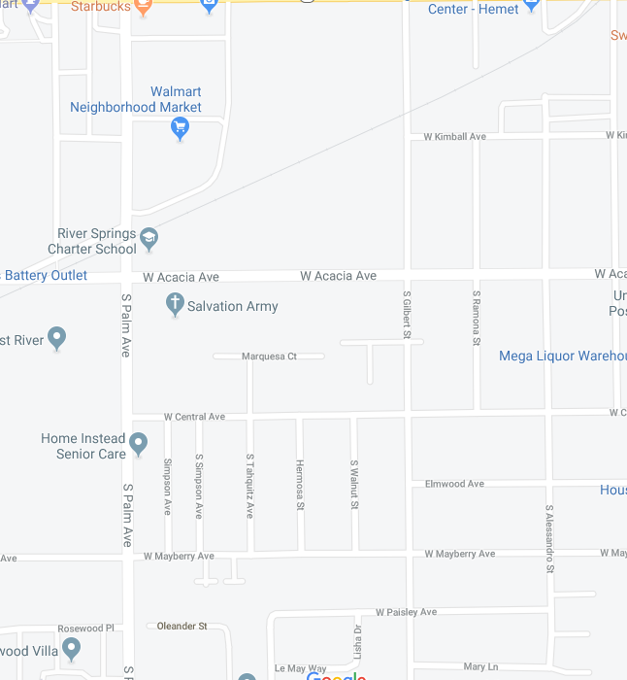
Recommendation: Dropping off cadets at West Mayberry Ave and S. Palm. Cadets should walk up palm to our designated spot (34).
Temporary Parking for parents dropping off children in the parade will be in Salvation Army Parking lot. Please enter from Mayberry and exit east on Mayberry.
Check in and Drop Off: Due to the danger, no one is permitted to drop off at Starbucks/Walmart Parking lot.
Time: 8:15-8:45 am. Please have your child arrive between 0815-0845. Attendance will be taken and participation graded.
Location: Spot 34. There will be poles with designated numbers on S Palm, look for the spot 34. There will be numerous Parade officials in the area that can help guide you and we are clustered near the rest of the Hemet High School participants (band, Theater, cheer and dance).
Uniform: Short Light blue jacket with a tie/tab and hat. Cadets may where black gloves while waiting but once parade starts they will need to be removed and stored in their jacket pockets.
Recommendations:
Beverages. Bring a disposable water bottle or hot beverage that can be discarded in trash. Cadets will not be allowed to carry a hydro-flask or any other item while marching in formation.
Inclement Weather Plan. If it is raining, instructors will send out a notification cancelling our participation by 0700 Saturday morning, using Remind App, Blast, and Email.

