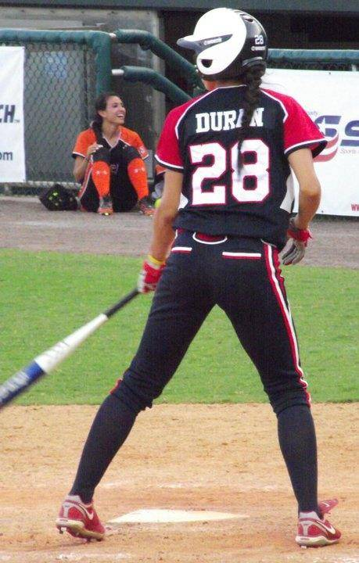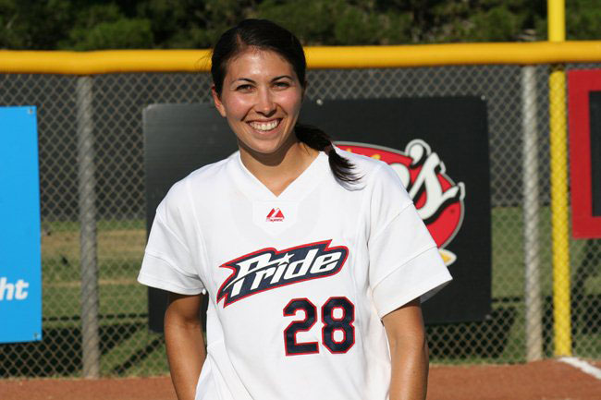
ANDREA DURAN SOFTBALL CLINIC
Andrea Duran is a UCLA graduate, Olympic silver medalist and 2- time World Cup Champion. She played in the National Professional Fastpitch league for the USSSA Pride for 9 seasons and most recently was selected to the ALL DECADE TEAM. She is coming to KOKOMO for a softball clinic! Each session will include Q&A and autographs.
WHEN: February 23, 2020 WHERE: Western Highschool field house
COST: $25 or $200 per team (limit of 15 players) TIME: Ages 7-11 from 8:30 – 11:00
TIME: Ages 12-18 from 11:30 – 2:00
Mail form and payment to: Jim Clouse 310 Cedar Ct. Kokomo IN 46902 Email jrclouse@comcast.net
SLOTS ARE LIMITED AND WILL BE GIVEN ON A FIRST COME FIRST SERVE BASIS
Player NAME:__________________________________ Coaches Name: __________________________
ADDRESS: ________________________________________City__________________ ZIP:___________
Phone Number: __________________________ Parent Name ________________________
Amount enclosed: ________________________ Check #_____________________ Cash:______________
ANDREA DURAN PARTICIPATION WAIVER
I hereby consent ____________________________________, to participate in the Andrea Duran Softball Clinic on February 23, 2020 at Western High School Fieldhouse. Furthermore, I hereby acknowledge that there are inherent risks associated and accompanied with this softball clinic and that the participant listed above may be injured as a result of an accident arising out of participation in this event.
**The Andrea Softball clinic will not be liable for any and all injuries or damages sustained by the individual participating in this event.
Guardian Print ____________________________________________________ Date: _______
Guardian Signature _________________________________________________

