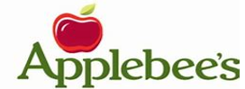
PANCAKE BREAKFAST FUNDRAISER!
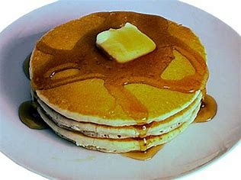
Please join the N.L.A.A. Bears- Jr. Varsity/Varsity Football Team
for a Pancake Breakfast!!

Our team would be honored to provide you with excellent service for a great morning start.
When: Sunday, October 14th, 2018
Location: Applebee’s Restaurant
12600 Day St
Moreno Valley, CA 92553
Time: Serving time is from 8:00am – 10:00am
*last seating at 9:45am

Cost: $10 per ticket (1 person per ticket)
Meal includes: Pancakes, sausage, scrambled eggs and beverage (coffee, tea, juice)

All proceeds will be used for Team Banquet,
and coaches/player gifts.

Thank you in advance for your support!!
For More Information, contact: Camelia Beavor at 951-377-4382
Please make checks payable to NLAA BEARS

