PARENT/COACH INSTRUCTIONS!

Log In and check notifications for any invites sent by coach or admin
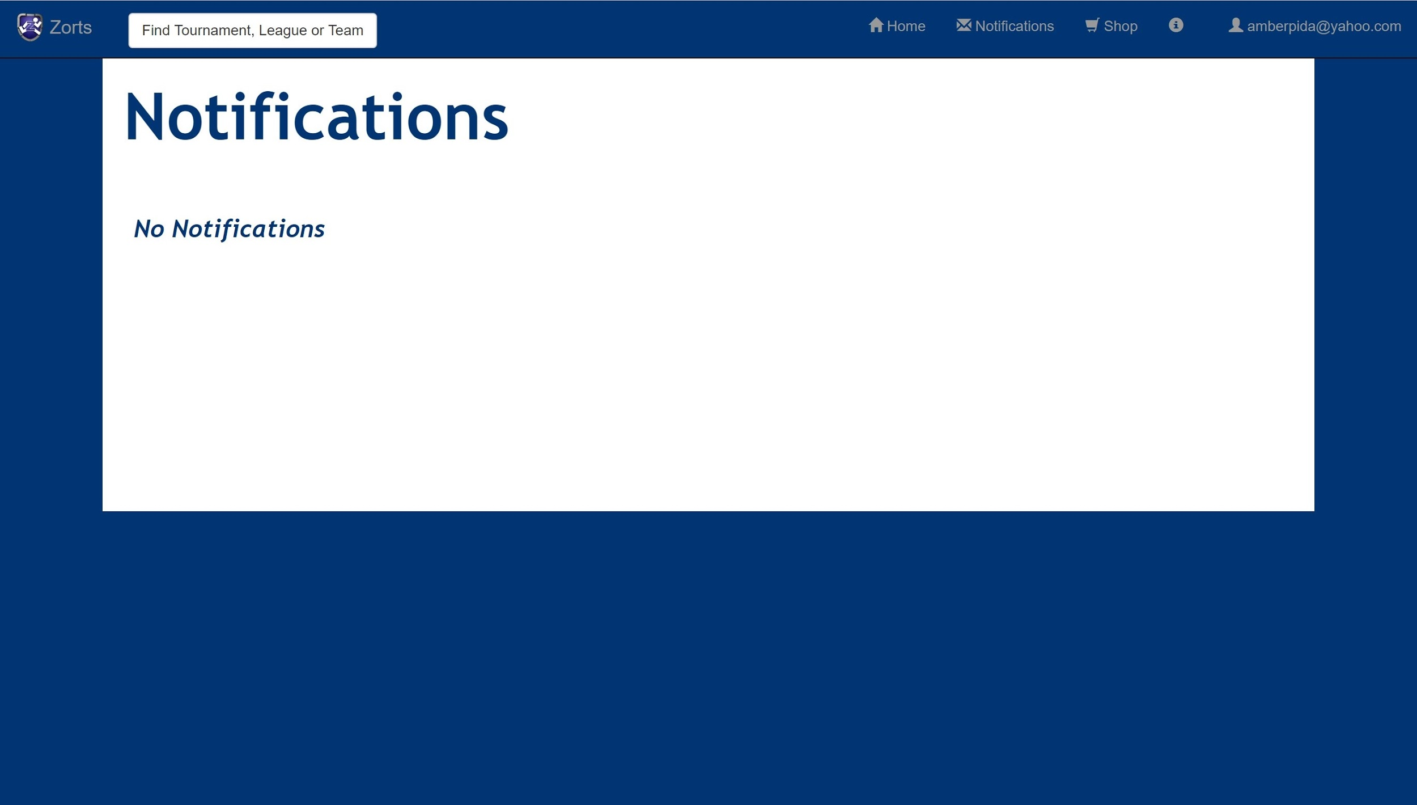

Go to “My Teams” select your profile
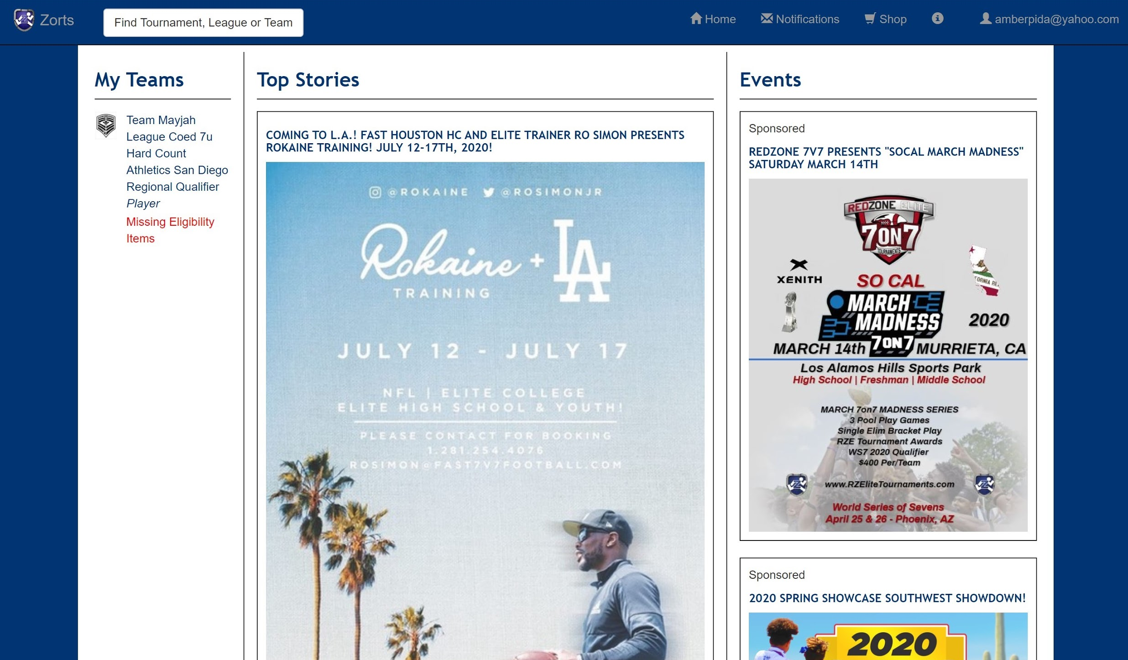
You will have the details appear at the top of any items missing and a remainder of the registration deadline.
It is important to fill the rest of the information under “Player Details”
If you already have a player card then a drop down will appear and you can select the name.
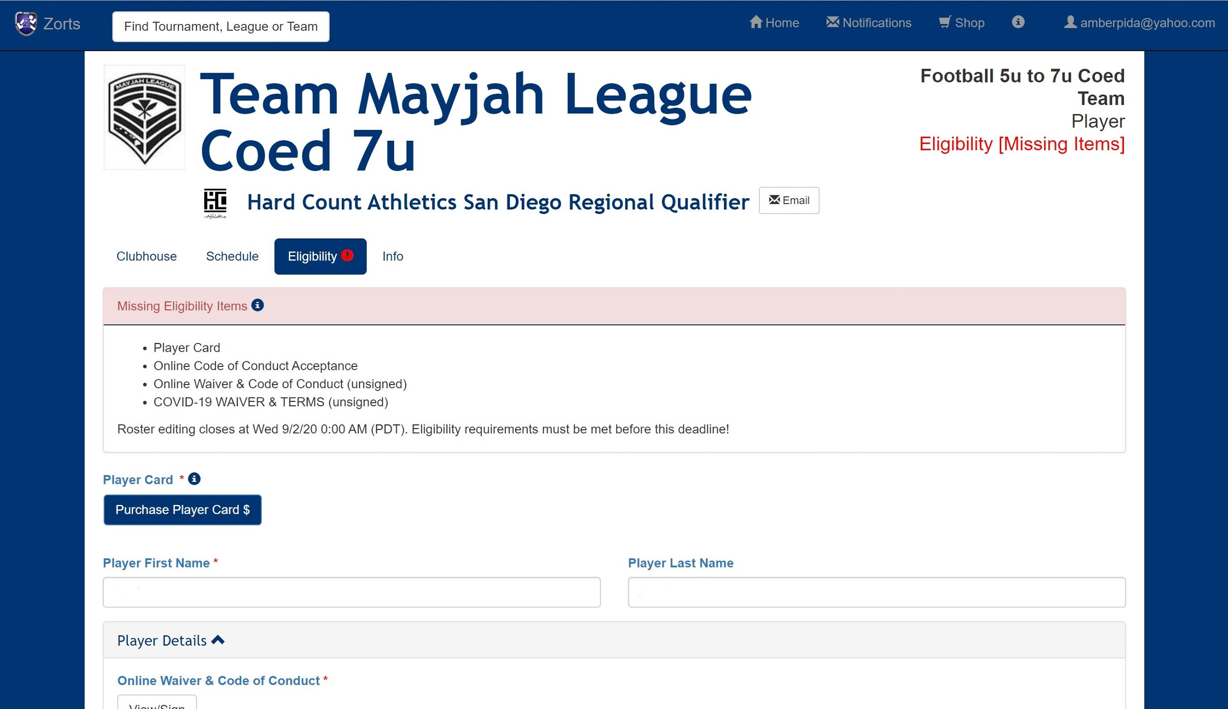
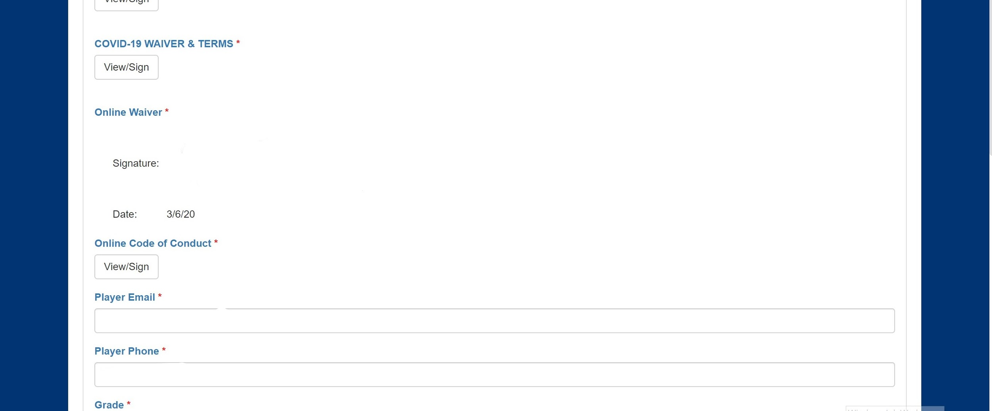

Parents who have not created any profiles
Use the search bar to look for the event you are participating in
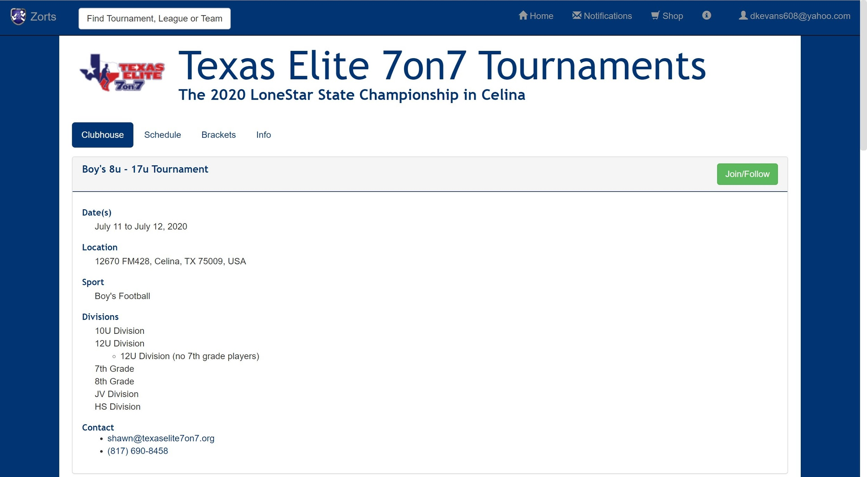

Select “Join/Follow”
Select the Role “Parent”
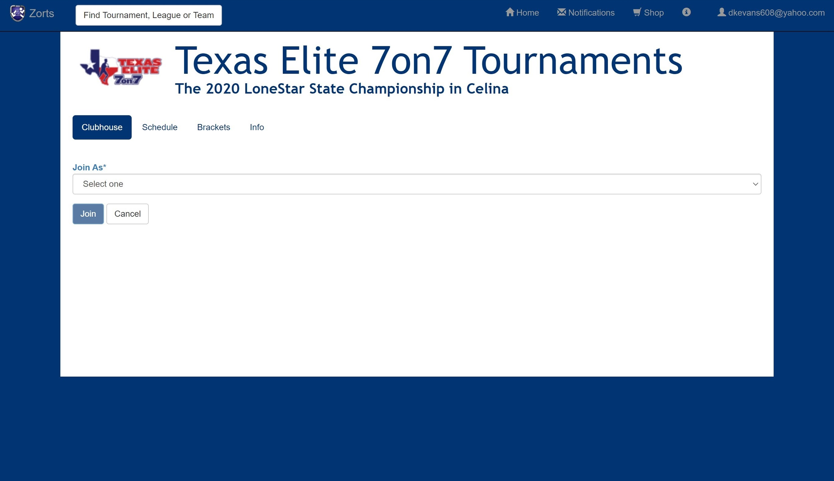

Purchase or Connect Player Card Here

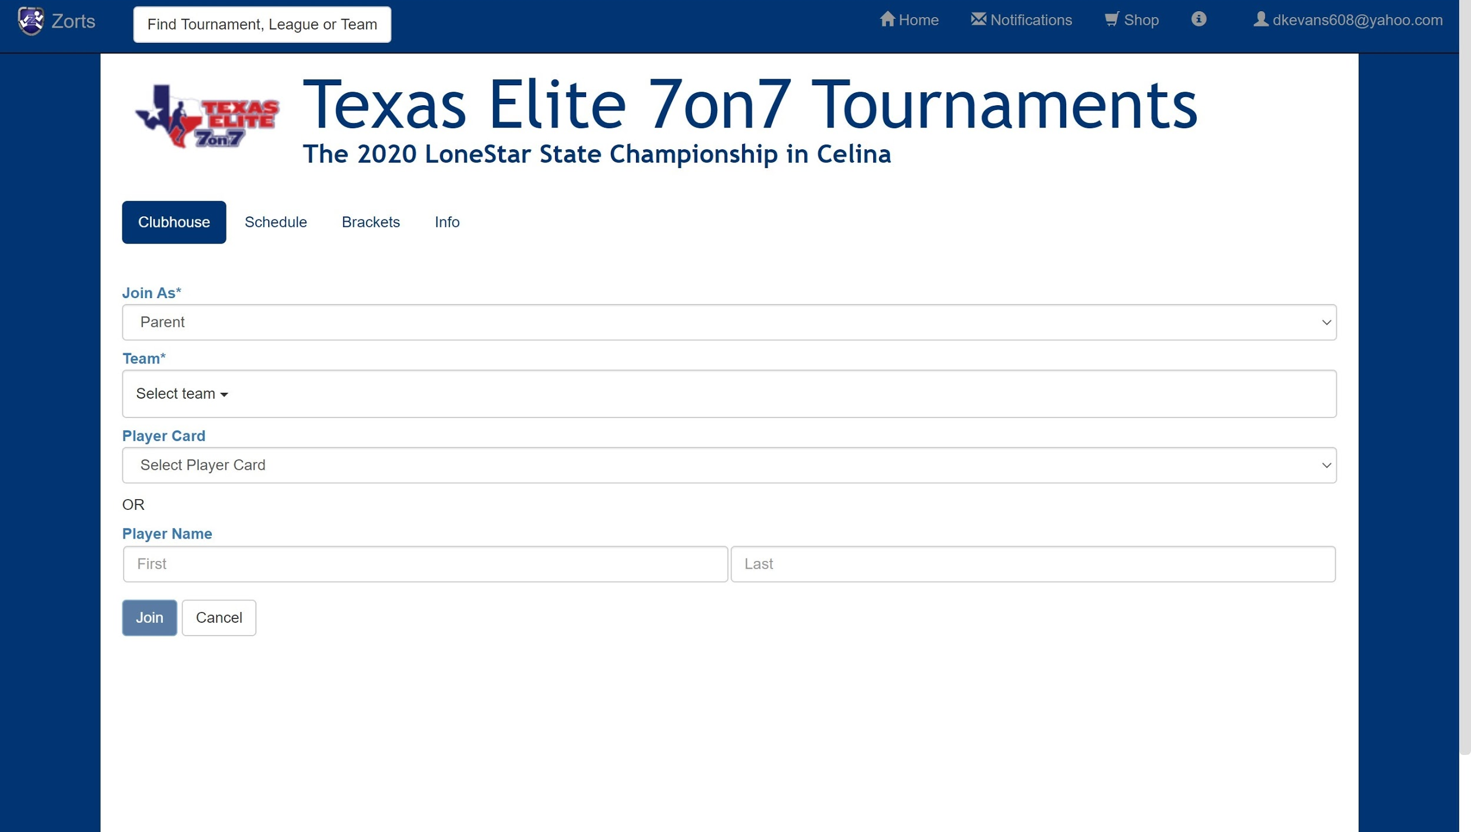

Coach
After registering select your team under “My Teams”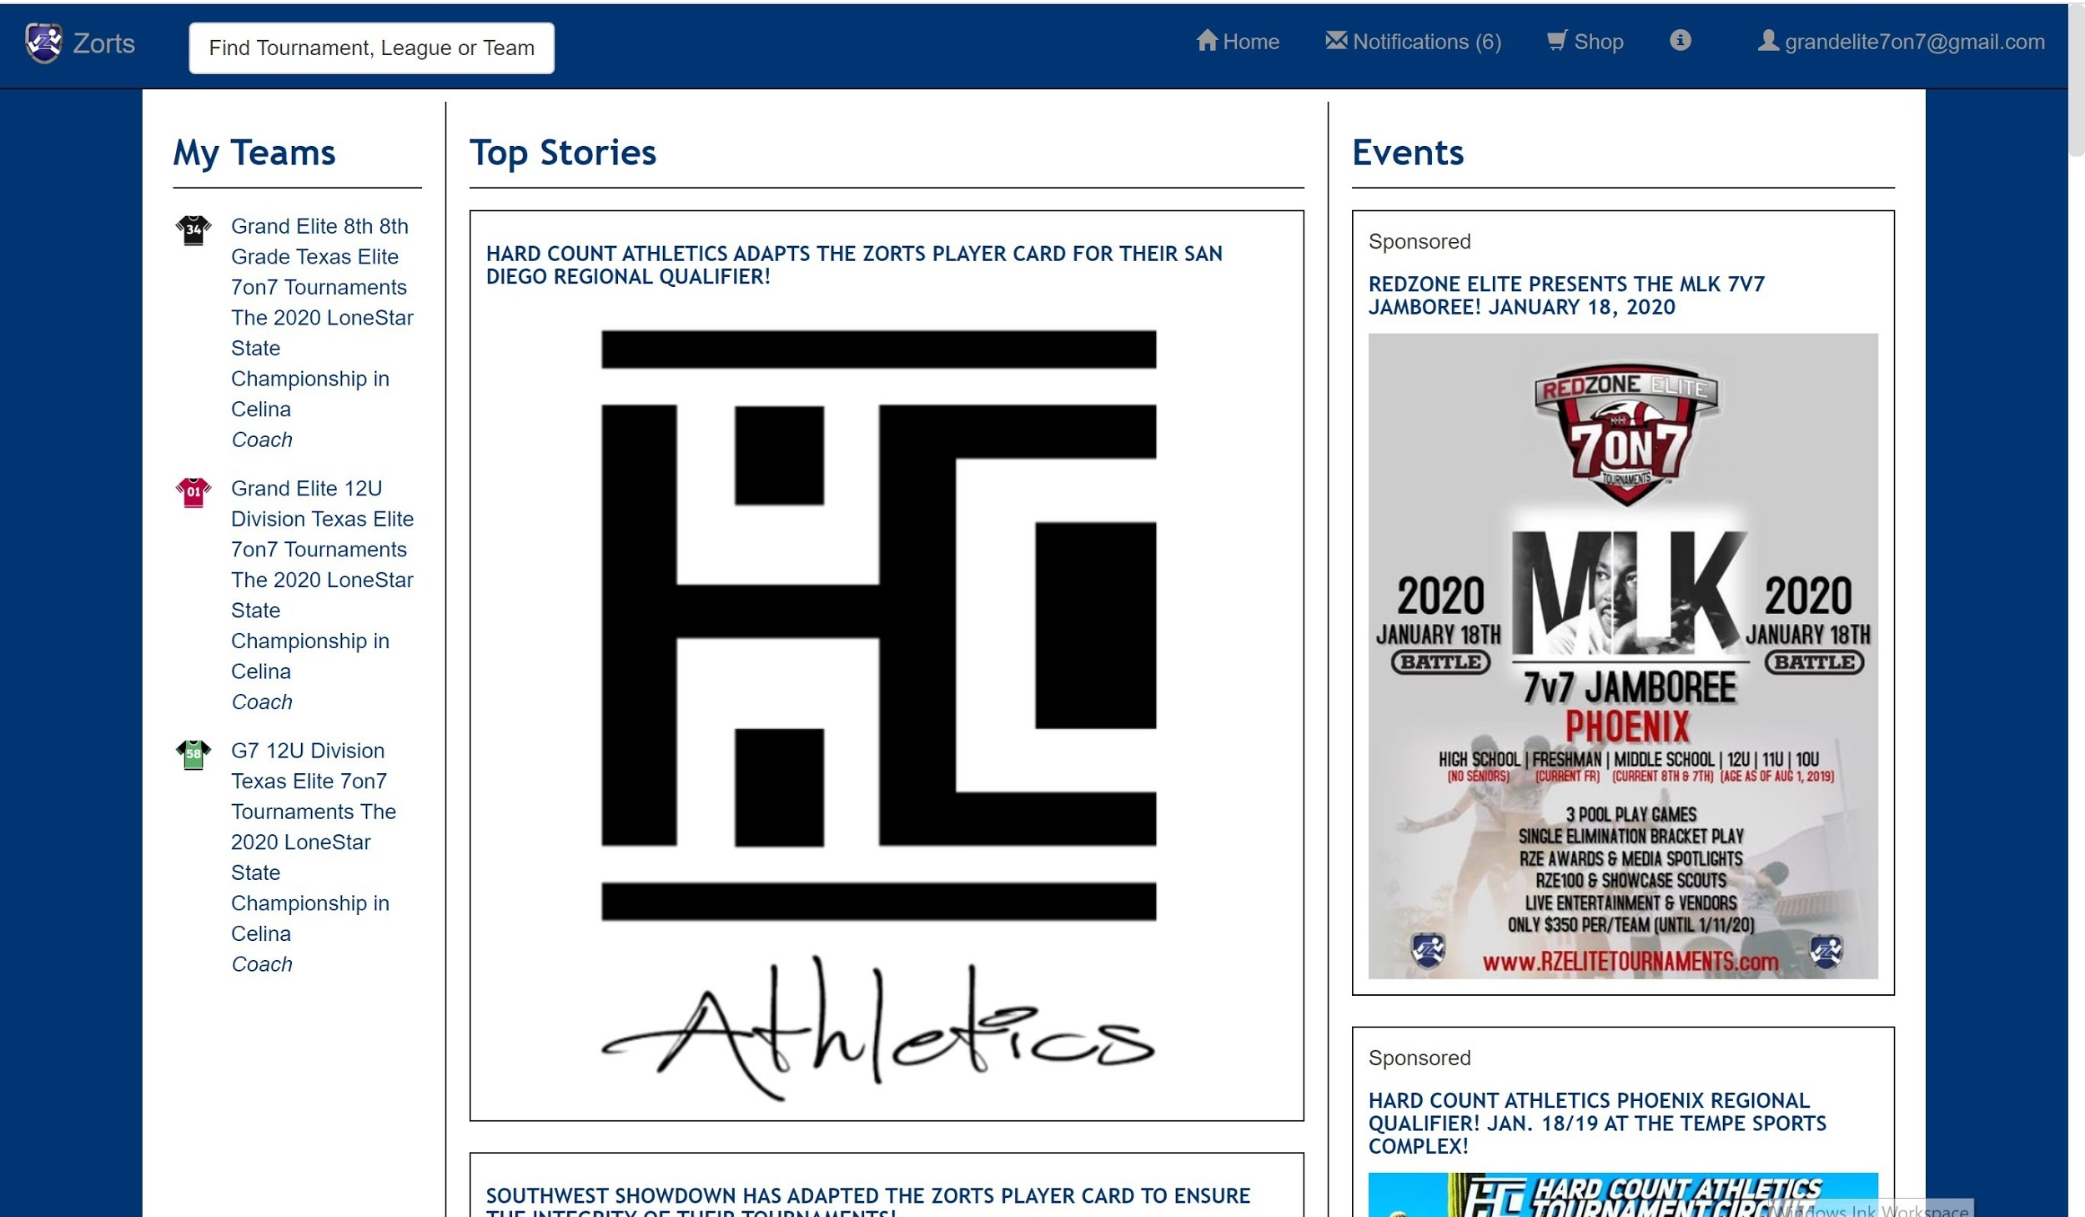

Select “Roster” and “Players” to add to your roster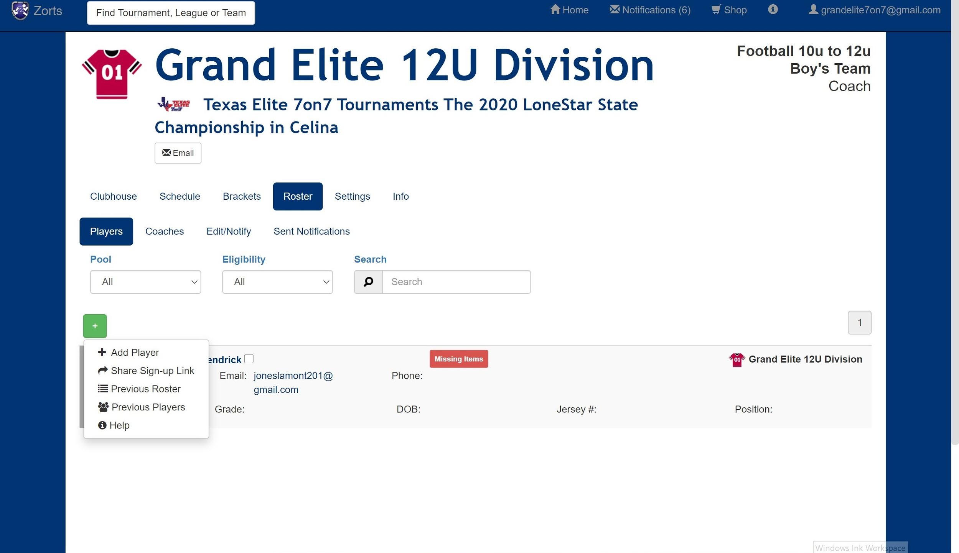

To share the link select “Settings”
