EMPORIA STATE TEAM CAMP 2021

ATHLETE INFO SCHEDULE
Name: _____________________________ 9:30 AM – Meet at the Fieldhouse
Grade ________________ Age ______ 10:00 – Busses Depart GHS
Student Cell # _______________________ 11:45 – Golden Wok Buffet Emporia
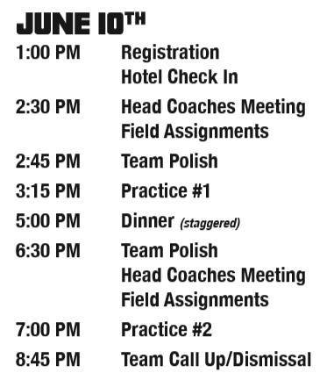
Student Email _______________________
Twitter _____________________________
GPA/Test Score ______________________

Parent Name(s) _______________________
Parent Email _________________________
Address _____________________________
Parent Phone # _______________________

Medical Insurance Company
____________________________________
Policy # _____________________________

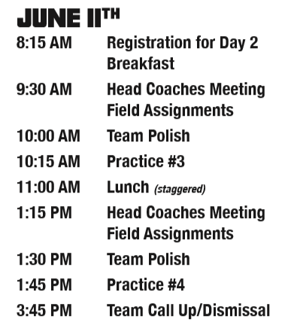
LIABILITY WAIVER
I hereby state that the Emporia State Football Camp is not responsible for any pre-existing injury or recurrence of any undisclosed pre-existing injury or illness of the camper. I also authorize the directors of the Emporia State Football Camp to act for me according to their best judgment in an emergency requiring medical attention. I further acknowledge that Emporia State University or anyone else associated with the Emporia State Football Camp will not be liable for any damage from injury or illness sustained at the Emporia State Football Camp.

Athlete Signature:
__________________________________________
Parent Signature:

2021 Emporia State Team Camp
Player Packing List
Room and Toiletries:
- Bedding – Sheets / Blanket / Pillow
- Towel
- Toothbrush
- Tooth Paste
- Deodorant
- Soap / Shampoo
- Talc / Baby Powder

Personal Needs:
- Shorts
- T-Shirts
- Sweats / Hoodie
- Socks
- Underwear
- Workout Shoes (tennis shoes)
- Phone Charger
- Pizza Money ($20)

Football Needs:
- Helmet
- Guardian Cap
- Shoulder Pads
- Practice Jersey
- Mouthpiece
- Girdle
- Cleats
- Travel Bag
- Gloves (Optional)

Optional:
- Slides / Shower Shoes
- Sunscreen / Bug Spray
- Fan
- Trash bags for laundry
- Headphones

