You are invited to the
2018 Fontana Pop Warner
Tiny Mite Dragons
End of Year Party

ALL OUT
ALL GAME
ALL SEASON
1500 W. 7th Street
Upland, CA 91786

Friday, December 21st
6:00pm – 9:30pm

FOOD - GAMES - GIVEAWAYS - AWARDS
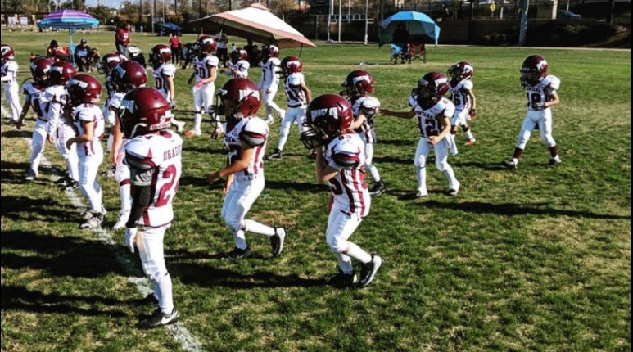
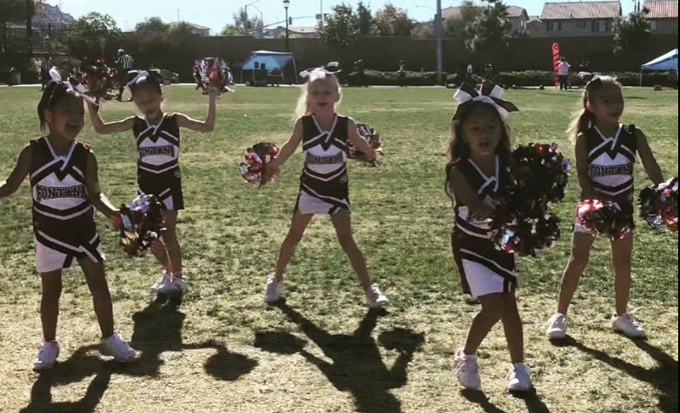

Come party with the Dragons as we celebrate a great year of hard work and team work!!!

