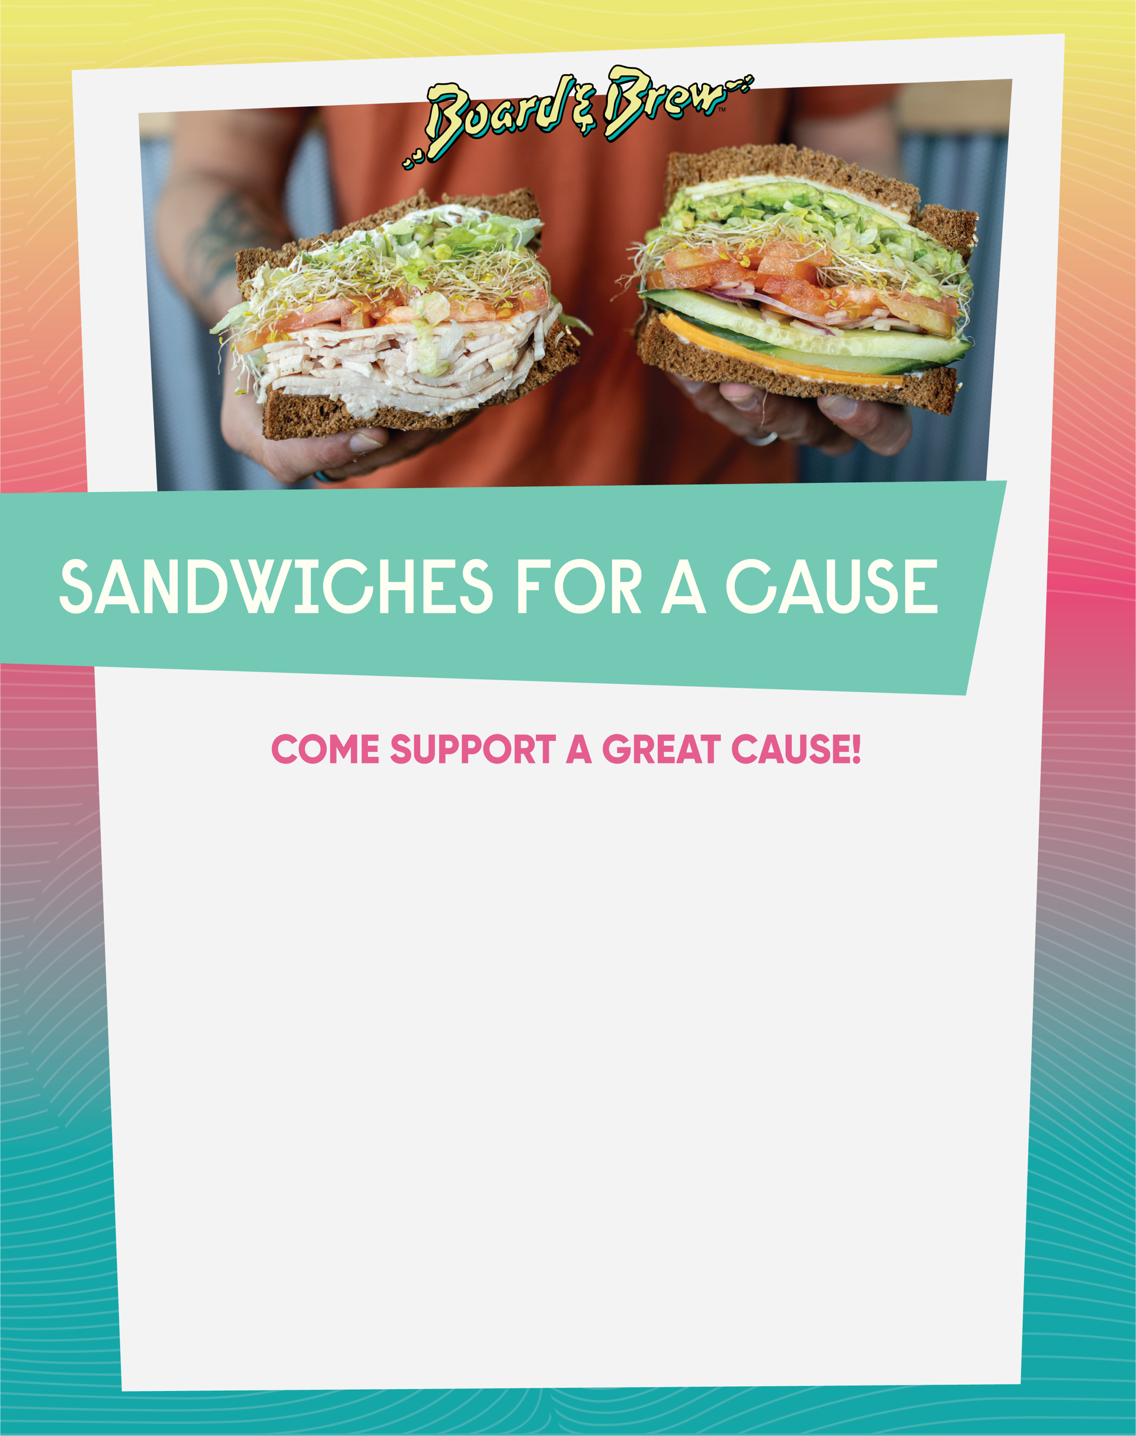

20% BACK to Poway High School Basketball

Please join us and enjoy incredible sandwiches, salads and chips!
Spread the word to your friends and family!

Date: January 13| Time: 4-8:00 pm

Please bring printed flyer/show on your smartphone to receive fundraiser credit

Call ahead/place your order for easy pick up

*Fundraiser credit not available for online orders*

Board & Brew Poway / 13501 Poway Road
760-331-3757

