How to make sure you are signed up for North County Panthers on AAU

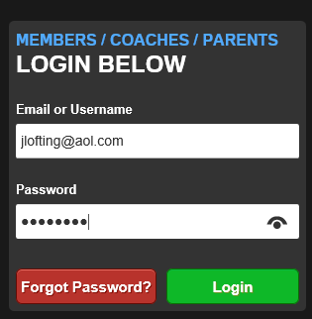
Step 1: log onto - https://play.aausports.org/login
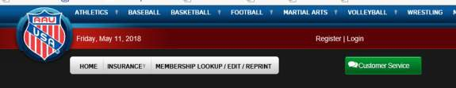
Step 2: Log into your account

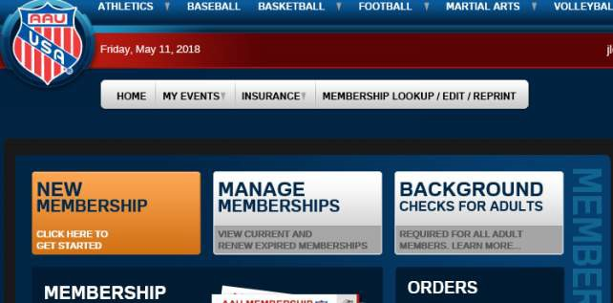
Step 3: Click on the Manage Memberships button

Step 4: Click on the edit button

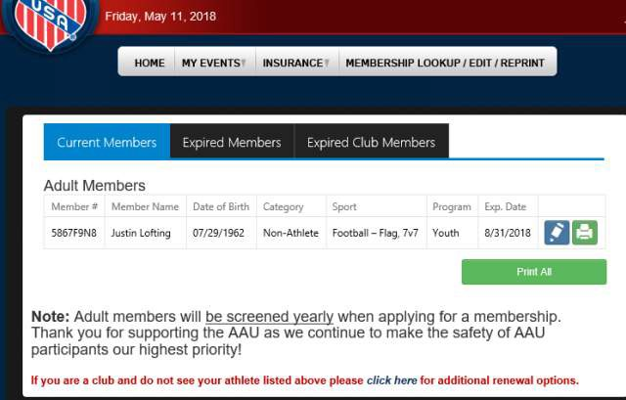
Step 5: Make sure the W36WF5 code is in the club code Step 6: Make sure the sport is Football - Flag, 7v7-- Then click SAVE

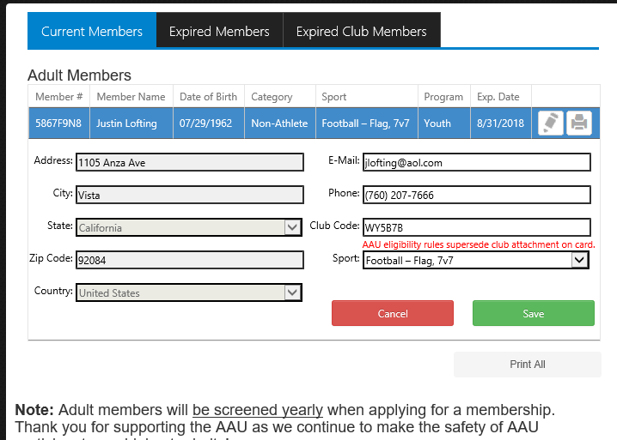
Our Code is: W36WF5

