Please make all checks out to Saugus XC.
Turn in your uniform order by Friday, 6/24, to Coach Berns.
$80.00 Cash or Check Accepted. ($40 for top, $40 for bottoms)
Contact Michelle Velikorodnyy (805) 404-4982 if you need more time or assistance for payment.
Images provided for style preview only.
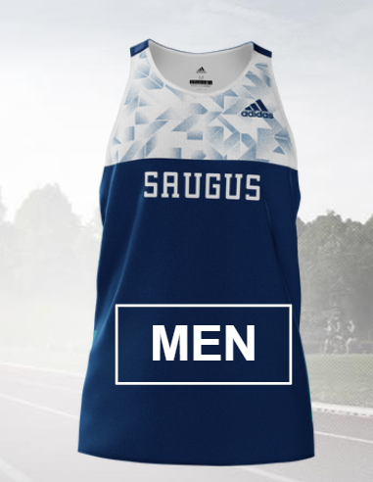 OR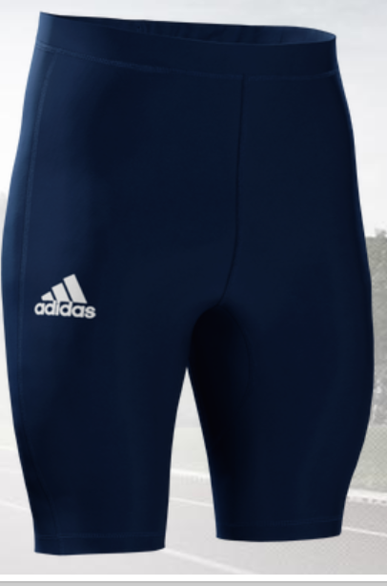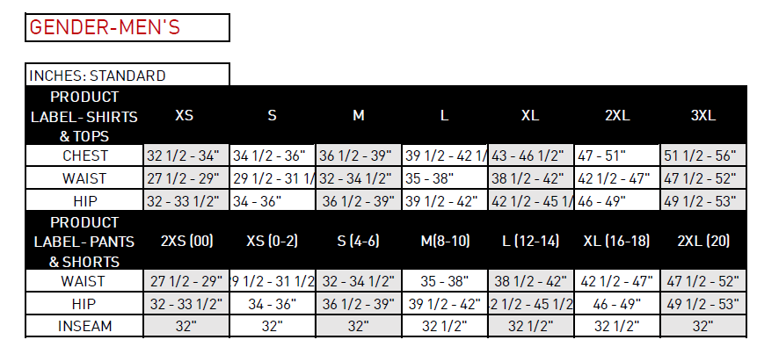

Athlete’s Name:
Top ($40) Size:
Bottom ($40 each) Size: Bottom Style: shorts or tights
(For planning purposes)Hoodie size:

Please make all checks out to Saugus XC.
Turn in your uniform order by Friday, 6/24, to Coach Berns.
$80.00 Cash or Check Accepted.
Contact Michelle Velikorodnyy (805) 404-4982 if you need more time or assistance for payment.
Images provided for style preview only.

OR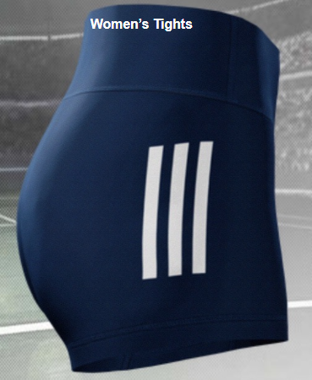
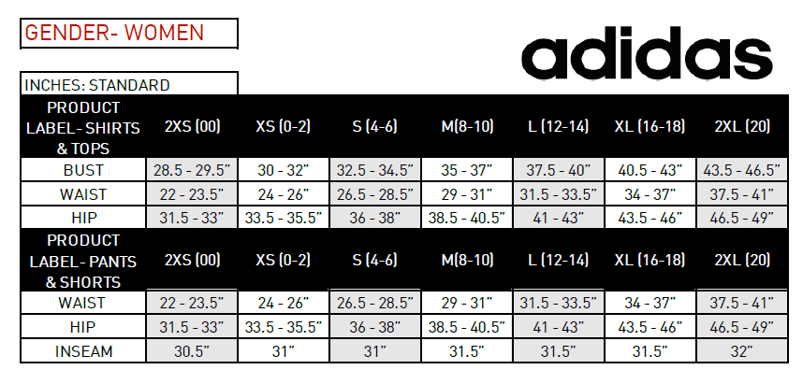

Athlete’s Name:
Top Size:
Bottom Size: Bottom Style: shorts or tights
(For planning purposes)Hoodie size:

